EXPERIMENT-7
Description:

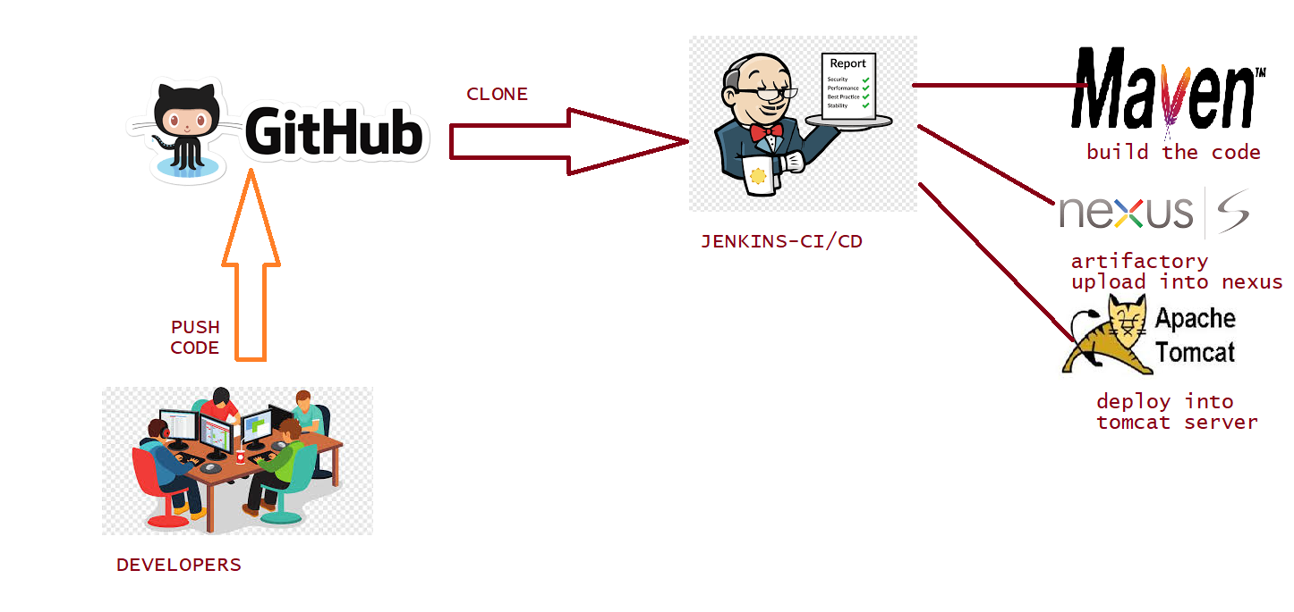

Jenkins is an open source automation tool written in Java programming language that allows continuous integration.
Jenkins builds and tests our software projects, which continuously making it easier for developers to integrate changes to the project, and making it easier for users to obtain a fresh build
With the help of Jenkins, organizations can speed up the software development process through automation. Jenkins adds development life-cycle processes of all kinds, including build, document, test, package, stage, deploy static analysis and much more.

Jenkins Freestyle Project: It is a repeatable build job, script, or pipeline that contains steps and post-build actions. It is an improved job or task that can span multiple operations. It allows you to configure build triggers and offers project-based security for your Jenkins project. It also offers plug-in to help you build steps and post-build actions.
The types of actions you can perform in a Jenkins build step or post-build action are quite limited. There are many standards plug-in available within a Jenkins Freestyle Project to help you overcome this problem.
The freestyle build job is a highly flexible and easy-to-use option. You can use it for any type of project; it is easy to set up, and many of its options appear in other build jobs. Below is a step by step process to create job in Jenkins
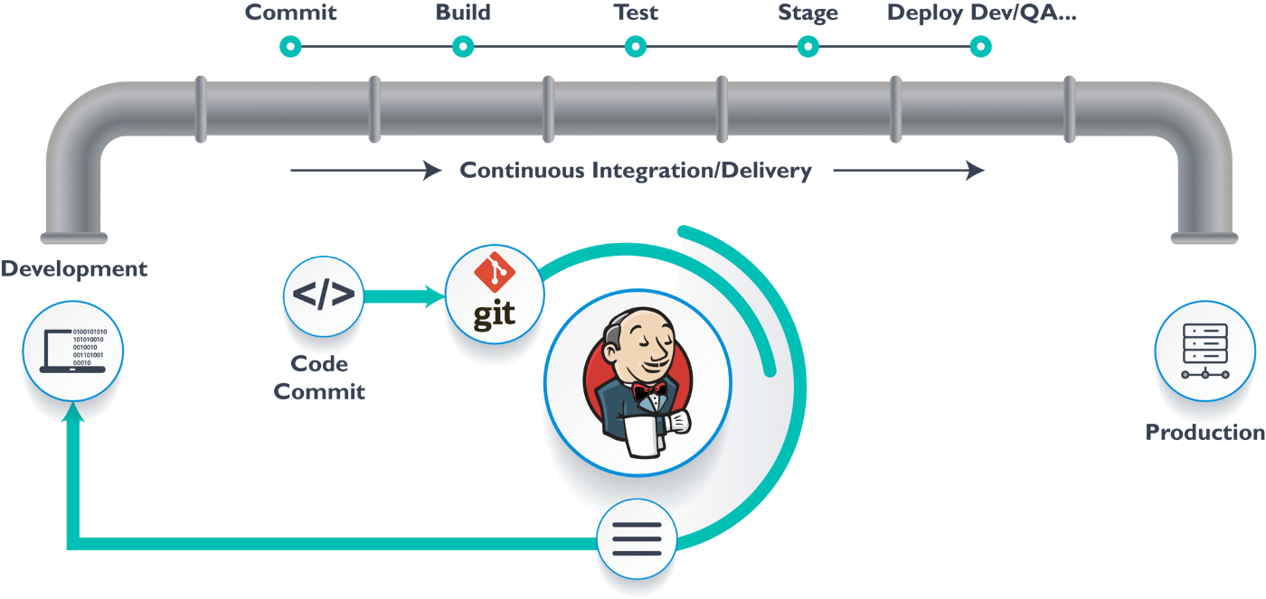
Apache-tomcat-server:
Apache Tomcat is a popular open source web server and Servlet container for Java code. It's a production-ready Java development tool used to implement many types of Java EE specifications. Apache-tomcat server runs on 8080 port number.

Procedure:
The freestyle build job is a highly flexible and easy-to-use option. You can use it for any type of project; it is easy to set up, and many of its options appear in other build jobs.

Launch ec2-Instance:

- Amazon Linux-Select
- T2-Micro-Next
- Number of instances-1-Next
- Next(storage section)
- click to add a Name tag: JENKINS– Next
- Security group name: JENKINS and give the port numbers like TCP 8080, HTTP
80 and HTTPS 443
- Description: Devops-SG
- Review and Launch-Launch
- Create a new key pair-demo-Download key pair-Launch
- Instances-Click on Instance ID
- Click on Instances(Can see Linux machine running)
- After login to server, to install Jenkins package

JENKINS-INSTALLATION:
1 sudo amazon-linux-extras install epel -y
2 sudo amazon-linux-extras install java-openjdk11 -y
3 java -version
4 sudo wget -O /etc/yum.repos.d/jenkins.repo https://pkg.jenkins.io/redhat-stable/jenkins.repo
5 sudo rpm --import https://pkg.jenkins.io/redhat-stable/jenkins.io-2023.key
6 sudo yum install jenkins -y
7 systemctl restart jenkins
8 systemctl status jenkins
9 yum install git -y
10 git --version
11 yum install java-1.8.0-openjdk -y
12 yum install maven -y
13 mvn --version
APACHE-TOMCAT INSTALLATION:
1 sudo yum install java-1.8.0-openjdk -y
2 java -version
3 wget http://dlcdn.apache.org/tomcat/tomcat-9/v9.0.75/bin/apache-tomcat-9.0.75.tar.gz
4 ll
5 tar -zxvf apache-tomcat-9.0.75.tar.gz
6 ll
7 cd apache-tomcat-9.0.75/
8 ll
9 cd webapps/
10 ls
11 cd manager/
12 ll
13 cd META-INF/
14 ll
15 vim context.xml
Remove 2 lines like value and allow
16 cd ../../../
17 ll
18 cd conf/
19 ll
20 vim tomcat-users.xml
21 cd ..
22 ll
23 cd bin/
24 ll
25 ls
26 ./startup.sh

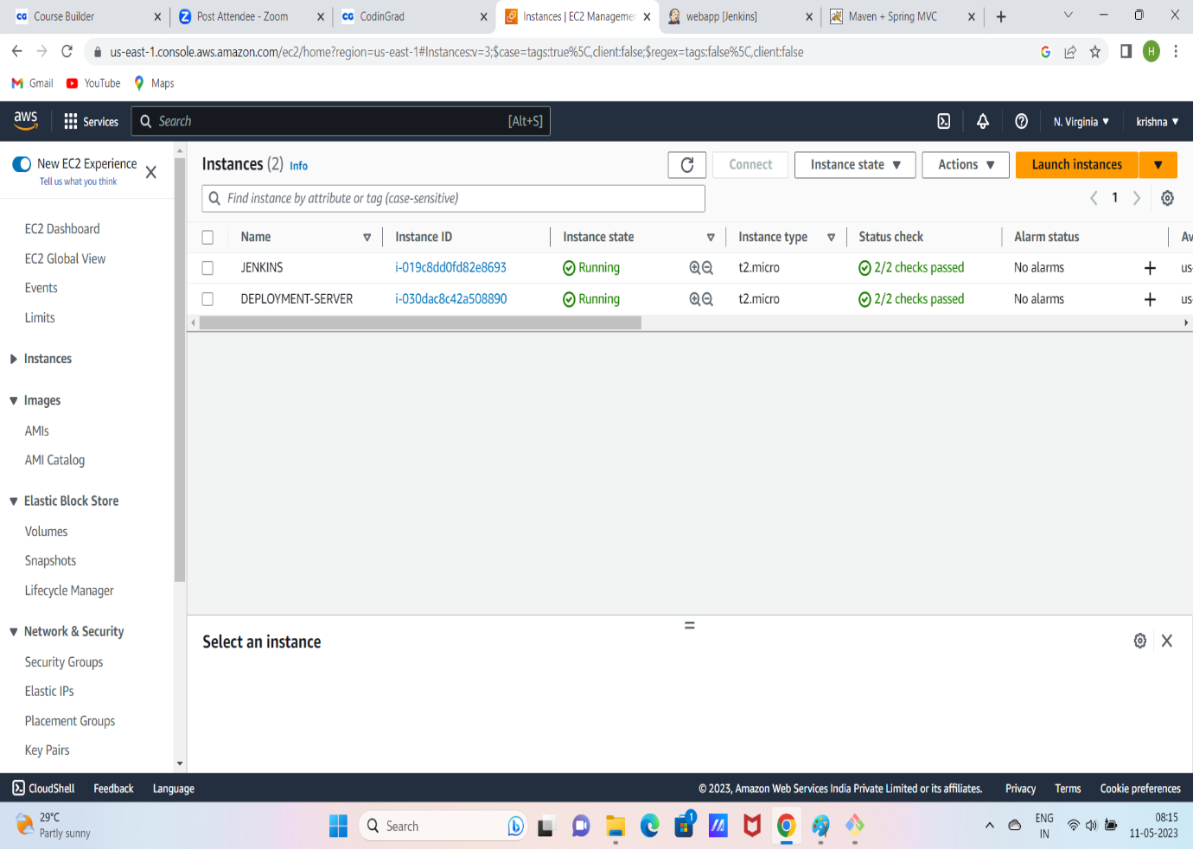

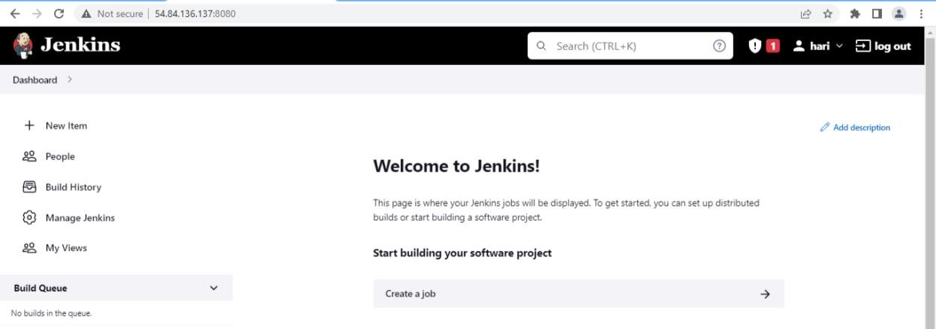

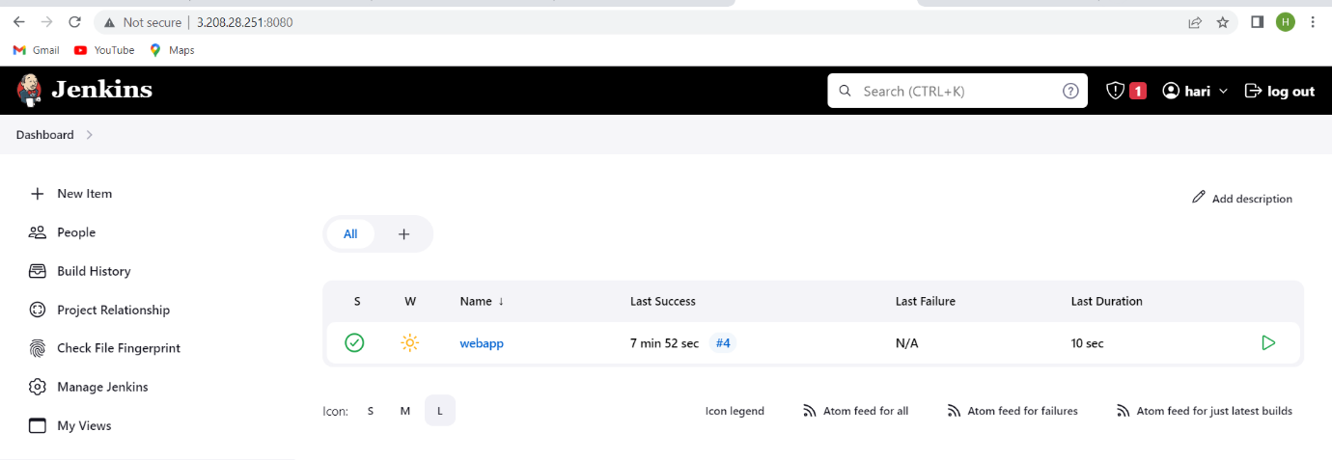

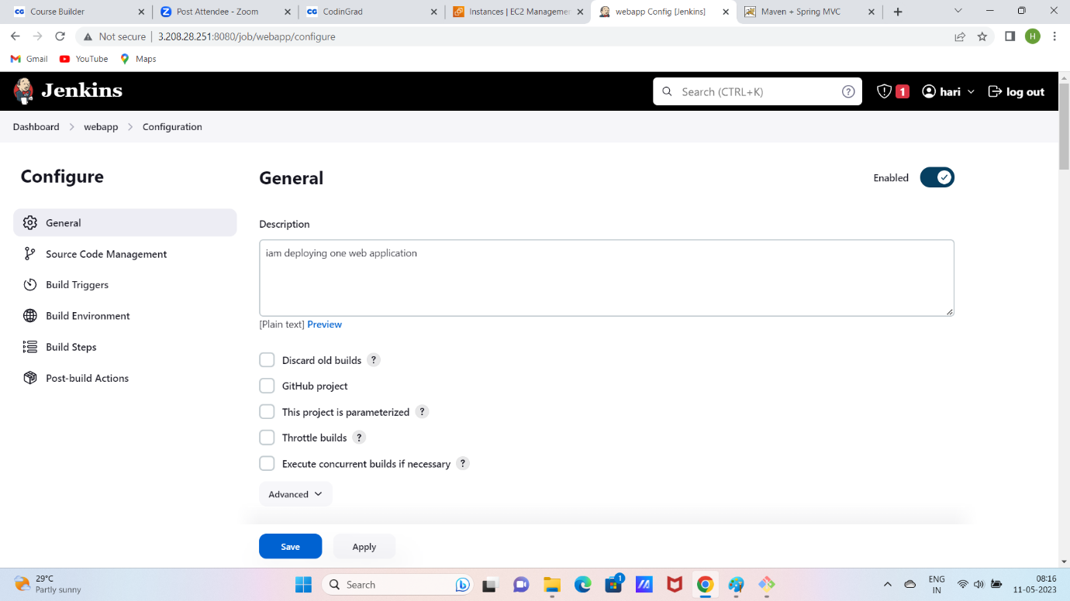

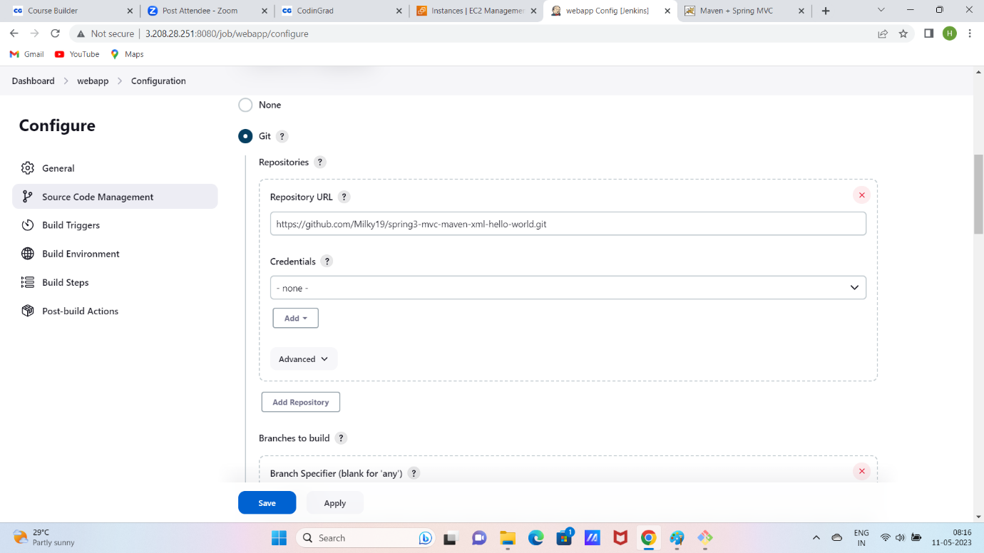

STEP: manage jenkins -----> global tool configuration ------> select maven option -- add maven version and path of maven
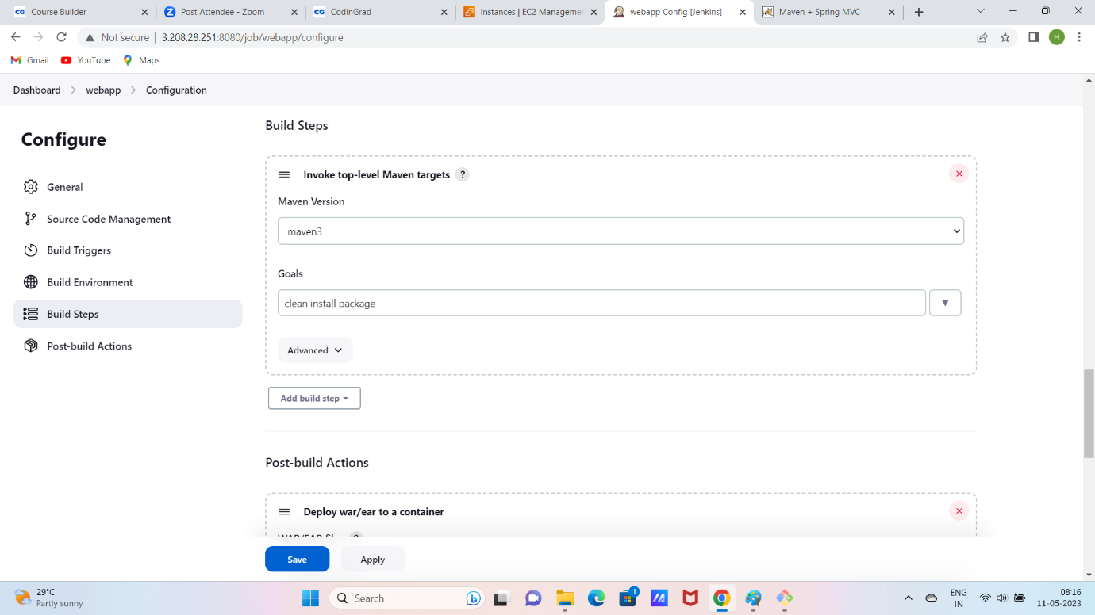
INSTALL DEPLOY TO CONTAINER PLUGIN
STEP1: manage Jenkins-----> manage plugin----> available plugin -------> DEPLOY TO CONTAINER
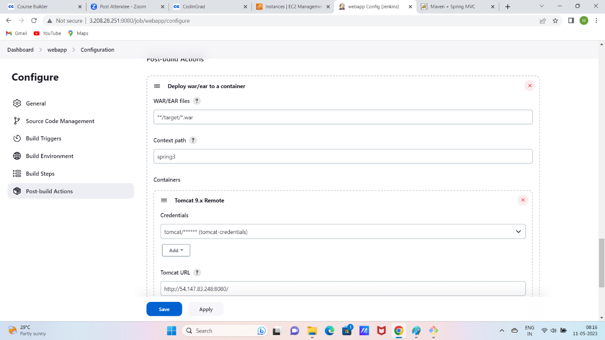

RESULT:

